## Assignment 2 – Question 2: Graphs printout

Suppose that we wish to calculate a result for $\int_{2}^{10}{\left(\log_{2}\left(x\right)\right)dx}$. Answer the following questions:

1. Draw the exact desired integral on the diagram below. (No calculations required.)

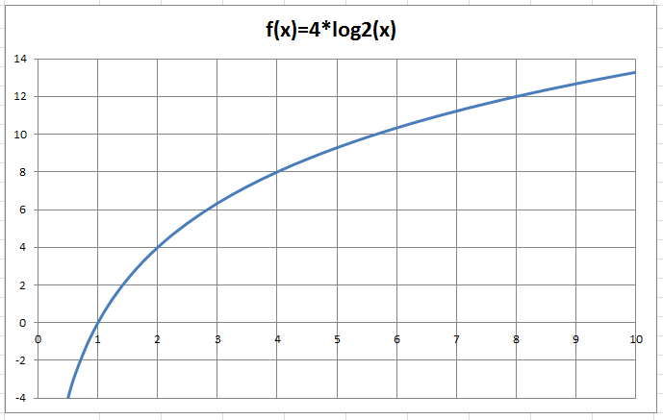

1. What is the approximation for the integral using one *trapezoid* (based on the trapezoid rule)? Show the trapezoid on the diagram below. Show your calculations and the result in the Excel workbook **A2q2 calculations.xlsx** in the **1Trap** sheet.



1. What is the approximation for the integral using two *trapezoids* (based on the trapezoid rule)? Show the trapezoids on the diagram below. Show your calculations and the result in the Excel workbook **A2q2 calculations.xlsx** in the **2Trap** sheet.



1. What is the approximation for the integral using four *trapezoids* (based on the trapezoid rule)? Show the trapezoids on the diagram below. Show your calculations and the result in the Excel workbook **A2q2 calculations.xlsx** in the **4Trap** sheet.



1. What is the approximation for the integral using eight *rectangles* (based on the left rectangle rule)? Show the rectangles on the diagram below. Show your calculations and the result in the Excel workbook **A2q2 calculations.xlsx** in the **8Rect** sheet.



1. What is the approximation for the integral using two areas with *2nd degree polynomial curves* (based on Simpson’s rule)? Show the two areas on the diagram below. Show your calculations and the result in the Excel workbook **A2q2 calculations.xlsx** in the **2Simp** sheet.



1. In the Summary worksheet in the **A2q2 calculations.xlsx** workbook, calculate the amount of error in each approximation from (b) through (f) by comparing the approximations to the calculated value from question 1(d). Express the error as an absolute amount and also as a percentage. Then fill in the answer below: For this integral, how many trapezoids are needed to be more accurate than the estimate using 8 rectangles?
2. Write your name(s) and SaskPolytech username(s) below: